The Circulatory System

What does the circulatory system do?

______________________________________________________________________________________________________________________________________________________

The circulatory system’s function is to transport things around the body. These are:

* __________________________
* __________________________
* __________________________
* __________________________

The circulatory system consists of the:

* _______________________________________________________________
* _______________________________________________________________
* _______________________________________________________________

Label the diagram of the heart below. Colour the oxygenated side of the heart red and the deoxygenated side blue.

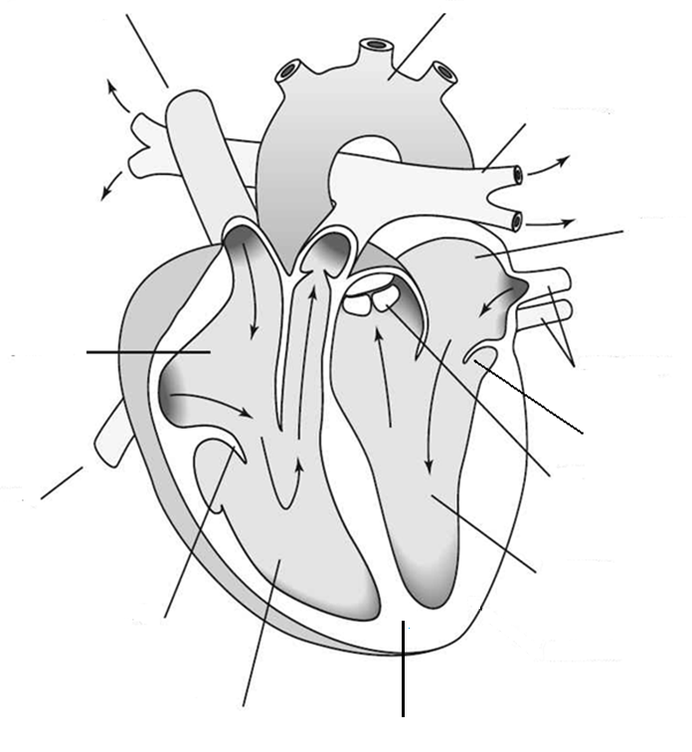

Describe the path blood takes from the vena cava though the heart.

_________________________________________________________________________________________________________________________________________________________________________________________________________________________________

Describe the path blood takes from the pulmonary vein though the heart.

_________________________________________________________________________________________________________________________________________________________________________________________________________________________________

Label the diagram below using the following sentences.

|  |
| --- |
| Oxygenated blood travels from the heart to the body |
| Blood travels from the heart to the lungs |
| Blood picks up oxygen from the lungs and gives out carbon dioxide |
| Oxygenated blood travels back to the heart |
| Deoxygenated blood travels from the body to the heart |
| Body cells use oxygen and give blood Carbon Dioxide |

Oxygenated blood travels from the heart to the body

Blood travels from the heart to the lungs

Blood picks up oxygen from the lungs and gives out carbon dioxide

Oxygenated blood travels back to the heart

DEOXYGENATED blood travels from the body to the heart

Body cells use oxygen and give blood Carbon Dioxide

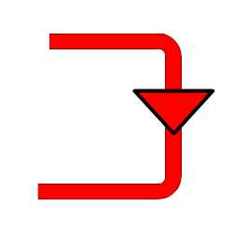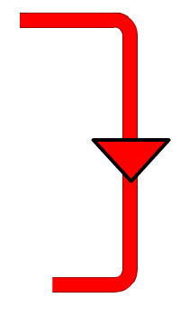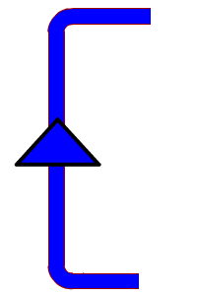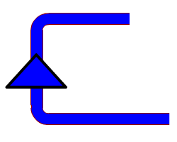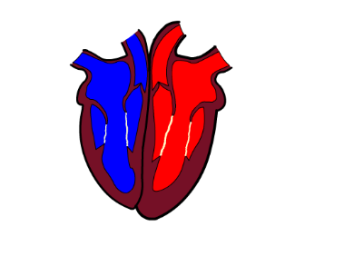

Body’s

cells

Lungs